LinkedIn Post

Photo Intelligence – Manage Your Photo Collections with automated Encoding & Recognition

Most of us have tens of thousands of photos—and no practical way to find people in them. Modern AI changes that.
Have you ever wondered how face recognition -often associated with surveillance- actually works? In this article, we explain not only how it works but we also show how you can use it yourself to manage the people in your own photo collections.
We demonstrate how to build an application that manages a knowledge base of named people. Starting from the basics, we gradually add more advanced functionality. The full source code, including setup instructions, is available for download. In coming posts we’ll explore additional photo management features that can be added to the application or used standalone.

Note: In this article, real people’s faces and names in illustrations have been intentionally obscured to protect privacy.
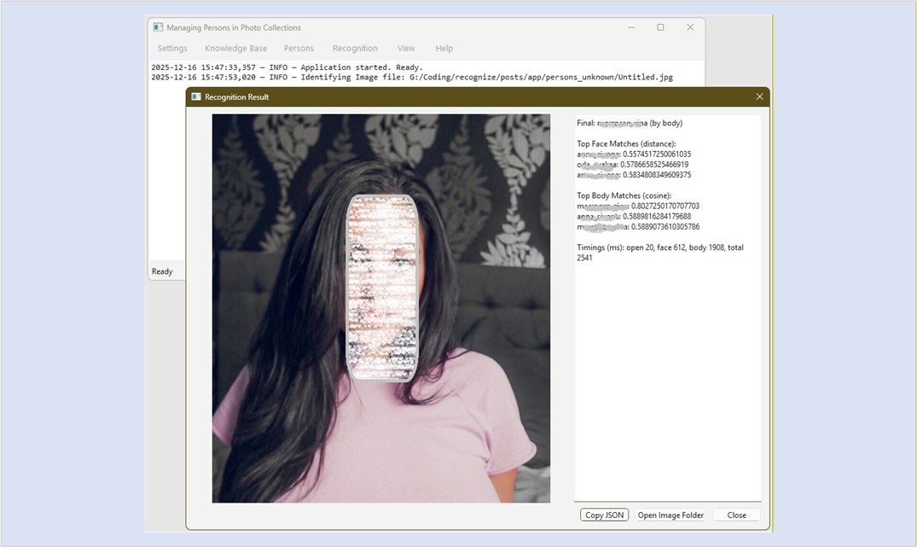
Figure 1. Person Identified.

Photo Intelligence
At Code2Trade.dev, our website dedicated to Data Science, Machine Learning & Applied Intelligence, we recently introduced a new topic: Photo Intelligence.
With the rise of digital photography most of us now have large collections - and large collections come with practical challenges:
- How do we find all the photos of a specific person?
- What to do with real or near-duplicate images?
- How do we keep photos taken with various devices neatly organized chronologically?
Deduplication and synchronizing will be addressed soon - but first, we need a solid foundation.

This series is aimed at Python developers, data scientists, and anyone curious about how production-grade face recognition actually works

Intelligent People Search
We kicked off this series with posts on automating the recognition and retrieval of people in large photo libraries. Surprisingly, even today it’s hard to reliably find all images of a given person—especially when collections are organized by people such as movie stars, sports heroes, models, or simply family and friends.

To manage people effectively, we need intelligent search – search that recognizes who’s in a photo. Thanks to recent advances in face recognition and person re-identification (ReID), much of this process now can be automated.

This series shows how to apply professional-grade techniques using approachable tools, allowing you to keep your photo library organized, searchable, and extensible.

An Introduction in 3 Steps
The introduction to this theme can be found in this post demonstrating that the basics of facial recognition are surprisingly accessible.

The key idea: a recognizer needs a knowledge base — a collection of previously encoded faces of known people.
A simple and effective dataset looks like this:

/persons dataset
/Person1
– image1.jpg
– image2.jpg
/Person2
– image1.jpg
– image2.jpg

Aim for 15–20 varied images per person (different angles, lighting, expressions). Folder names act as the labels the system learns.

Using this dataset, we build a batch photo recognizer in just three steps.

Step 1 — Encode Faces
We start with a small script that that scans the dataset, extracts 128-D face embeddings using DLIB-based deep learning, and stores them alongside person names.

# encode_faces.py
import os, pickle, pathlib
import numpy as np
import face_recognition

DATASET_DIR = pathlib.Path("persons_dataset")
ENC_FILE = "encodings.pkl"

encodings = []
names = []
for person_name in sorted(os.listdir(DATASET_DIR)):
person_dir = DATASET_DIR / person_name
if not person_dir.is_dir():
continue
for img_name in os.listdir(person_dir):
img_path = person_dir / img_name
try:
image = face_recognition.load_image_file(img_path)
# Optional: use 'cnn' model if you have a GPU and dlib compiled with CUDA
boxes = face_recognition.face_locations(image, model="hog")
face_vecs = face_recognition.face_encodings(image, boxes)
if len(face_vecs) == 1:
encodings.append(face_vecs[0])
names.append(person_name)
except Exception as e:
print(f"Skip {img_path}: {e}")

with open(ENC_FILE, "wb") as f:
pickle.dump({"encodings": np.asarray(encodings), "names": np.asarray(names)}, f)
print(f"Saved {len(encodings)} encodings for {len(set(names))} people to {ENC_FILE}")

That’s it, you just created your first photo knowledge base (KB).

Step 2 — Recognize Face(s) in an image
Next, we load the knowledge base, encode faces in a test image, and identify the closest known match using Euclidean distance. Strictness is controlled via a tolerance parameter.

# recognize_image.py
import pickle, numpy as np, face_recognition

with open("encodings.pkl", "rb") as f:
kb = pickle.load(f)

KNOWN = kb["encodings"]
NAMES = kb["names"]
TOLERANCE = 0.50 # adjust to taste

def recognize_persons(image_path):
image = face_recognition.load_image_file(image_path) # photo with person to identify
boxes = face_recognition.face_locations(image, model="hog") # or ‘cnn’
faces = face_recognition.face_encodings(image, boxes)
results = []
for face in faces:
dists = face_recognition.face_distance(KNOWN, face)
idx = int(np.argmin(dists))
if dists[idx] <= TOLERANCE:
results.append(NAMES[idx])
else:
results.append("Unknown")
return results

if __name__ == "__main__":
test_image = "test_image.jpg"
print(", ".join(recognize_persons(test_image)) or "No faces found.")

Processing a single image is not very efficient, so let’s make the script more useful.

Step 3 — Batch process a folder
Processing a single image is rarely enough. The batch version processes entire folders, automatically sorting images into subfolders by recognized person or Unknown.

# batch_process.py
import shutil, pathlib, time, pickle, numpy as np
import face_recognition

INPUT_DIR = pathlib.Path("E:/persons_unknown")
OUTPUT_DIR = pathlib.Path("E:/persons_processed")
ENC_FILE = pathlib.Path("E:/persons_dataset/encodings.pkl")
VALID_EXT = {".jpg", ".jpeg", ".png", ".webp"}
TOLERANCE = 0.45
MOVE_FILES = False # set True to move instead of copy

with open(ENC_FILE, "rb") as f:
kb = pickle.load(f)
KNOWN = kb["encodings"]
NAMES = kb["names"]

def save_to_bucket(img_path, label):
dest_dir = OUTPUT_DIR / label
dest_dir.mkdir(parents=True, exist_ok=True)
dest = dest_dir / img_path.name
if MOVE_FILES:
shutil.move(str(img_path), dest)
else:
shutil.copy2(str(img_path), dest)

def process_image(img_path):
try:
image = face_recognition.load_image_file(img_path)
boxes = face_recognition.face_locations(image, model="hog")
faces = face_recognition.face_encodings(image, boxes)
if not faces:
save_to_bucket(img_path, "Unknown")
return
# If multiple faces, save one copy per recognized label (dedup with a set)
labels = set()
for face in faces:
dists = face_recognition.face_distance(KNOWN, face)
idx = int(np.argmin(dists))
label = NAMES[idx] if dists[idx] <= TOLERANCE else "Unknown"
labels.add(label)
for label in labels:
save_to_bucket(img_path, label)
except Exception as e:
print(f"Error {img_path}: {e}")

def main():
start = time.time()
images = [p for p in INPUT_DIR.rglob("*") if p.suffix.lower() in VALID_EXT]
total = len(images)
for i, p in enumerate(images, 1):
process_image(p)
print(f"Progress: {i/total:0.1%} ({i}/{total})")
print(f"Done in {time.time()-start:0.1f}s")

if __name__ == "__main__":
main()

That completes the basic demonstration. In just three steps, we’ve built a working system to encode and recognize people in photo collections.

One Step Beyond
We just developed a small but genuinely working AI tool. What’s really happening under the hood? Like many AI systems, it’s built on pattern recognition. Using deep learning, software can be trained to distinguish traits, generalize and recognize them reliable.

Face recognition is a chain of related tasks:
- Detect face(s) in an image (something modern smartphone cameras already do).
- Normalize and align them across pose and lighting.
- Extract distinctive facial features.
- Compare them against known embeddings to identify the correct label.

The link referenced earlier (in Step 1) points to excellent work by Adam Geitgey, which explains these mechanics in depth.

Two-Signal System
In the next post things get serious.

We extend the pipeline with full-body person recognition, pairing face embeddings with Re-Identification (ReID) based on body shape and clothing. This two-signal system remains effective even when faces are small, occluded, or turned away.

Full-body recognition with TorchReID
TorchReID is widely regarded as a de facto standard for person re-identification. Built on PyTorch, it provides pretrained models, datasets, and evaluation pipelines tailored for cross-camera person matching.

We use the OSNet architecture and wrap it in a custom interface that abstracts away hardware selection, preprocessing, and normalization.

A Robust Face Encoder
Real-world images introduce many pitfalls: inconsistent color spaces, blurry faces, alignment issues, and detector failures.

Our encoder:
- Normalizes inputs to DLIB-friendly RGB buffers.
- Filters blurry faces using Laplacian variance.
- Escalates from HOG to CNN detection when needed.
- Aligns faces to a canonical frame.
The result is a consistent, auditable recognition pipeline.

The code for this two-sided toolbox is more advanced than the code shown above. You can find the development here.

Creating the Application
To tie everything together, we built a full Python + PyQt6 GUI. The codebase is modular, reusable, and structured around focused responsibilities.

The application framework:
- main.py, the entry point of the application, sets warning filters and boots the app;
- config.py, manages settings.json and shared constants;
- ui.py, the actual PyQt6 GUI that holds Main Window, Settings Dialog, Person Recognized Dialog -shown at the Intro- and the logging bridge).
The encoder & recognition toolkit:
- reid_wrapper.py, our full-body encoder, and
- face_encoder.py, our face encoder.
The application functions building on the toolkit:
- kb.py, the knowledgebase data model and the worker methods for batch encoding and searching plus the methods to manage individual persons in the KB;
- recognize.py, holds the worker methods for batch recognition.
In future posts these files are extended and adjusted but the structure remains intact.

Long-running tasks are handled via worker threads to keep the UI responsive, with real-time progress reporting. These workers are used to create and extend a second-generation knowledge base (KB) containing both face & body encodings.
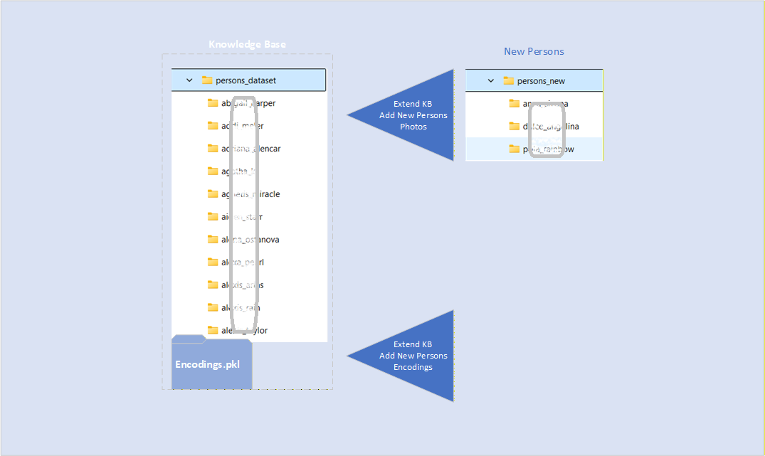
Figure 2. Batch Extending the Knowledge Base

We also make use of a worker method to build an enhanced menu-driven version of batch recognition, introduced in step 3 above!

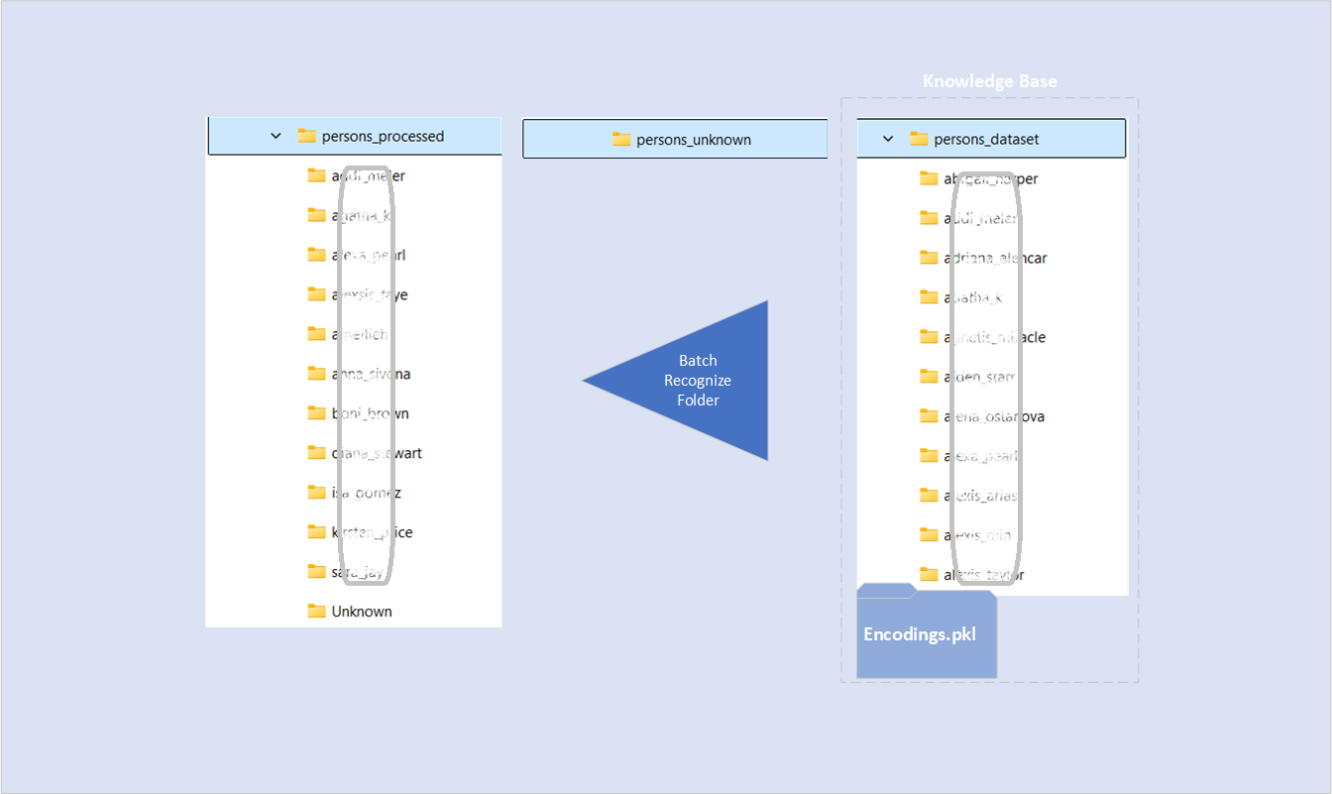

Figure 3. Batch Recognizing a Folder of Persons not yet Identified

Managing the Knowledge Base
The application supports:
- Adding, renaming, re-encoding, and removing people.
- Viewing statistics and KB overviews.
- Interactive searching optimized for performance.
More advanced photo-management features will follow in upcoming posts.

To manage the people in the KB the application has got menu operations to add, rename, reencode or remove people, editing the KB, and it can show a general overview of its content. The most recent addition to the application are functions for interactive searching. These make use of specialized techniques for optimizing performance.

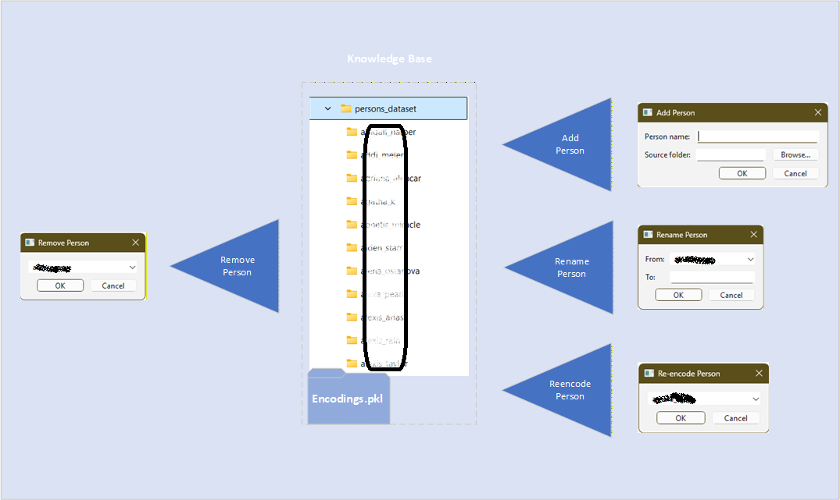
Figure 4. Editing the Knowledge Base

What’s Next?
Curious how far you can push personal photo intelligence?
In coming posts we’ll demonstrate additional advanced features that can be added to our application or used standalone.

Downloads
The complete Python source code for the People Recognition App is now available for download. Full source code and walkthrough on Code2Trade.dev.

